

**CODE OF PRACTICE**

**For the Application of Nutrients in New Zealand**

**The Spreadmark Code of Practice**

**Copyright Notice**

The term SPREADMARK® and associated logo are owned by Groundspread NZ (NZGFA). As the owner of the registered trademark, Groundspread NZ holds exclusive rights in New Zealand to use the registered trademark, authorise other persons to use the registered trademark, and assign or transmit the registered trademark to another. Any use of the SPREADMARK® wording or logo should be authorised by contacting the Executive Officer of Groundspread NZ ([eo@groundspreadnz.com](mailto:eo@groundspreadnz.com)).

The contents of this publication may be reproduced or transmitted in any form for personal, educational or research purposes, provided that the source of the materials is duly acknowledged as the Fertiliser Quality Council of New Zealand.

Otherwise, no reproduction or transmission of the contents of the publication may be made, either electronically or in hard copy form, without the express written consent of the Fertiliser Quality Council of New Zealand as the copyright holder. If you wish to use the contents of the publication in any manner other than as described above, please contact the Executive Director of the Fertiliser Quality Council of New Zealand.

**Document control**

All of the documents in the Spreadmark Code of Practice will be controlled. Each part of the Code and associated booklets will have the name, version date and page number.

Changes will only be made to the Spreadmark Code and associated documents after they have been approved by a Forum meeting of the Fertiliser Quality Council.

The updated version of the Spreadmark Code and associated documents will be placed on the website of the Fertiliser Quality Council ([www.fertqual.co.nz](http://www.fertqual.co.nz)).

**INTRODUCTION**

The Spreadmark programme was established by Groundspread NZ, formerly known as the New Zealand Groundspread Fertilisers’ Association Incorporated (NZGFA), in 1994. It was subsequently expanded by a group with representatives from Federated Farmers, Groundspread NZ (NZGFA), the NZ Agricultural Aviation Association (NZAAA), fertiliser companies, and the Fertiliser Association of New Zealand.

The Spreadmark scheme is a nutrient placement quality assurance programme. Its key objective is to ensure nutrients are applied in a way that delivers the most sustainable environmental and agronomical outcomes.

The scheme registers applicators, provided they have certified application unit, trained operators and appropriate quality management systems. Applicators are subject to regular independent audit to provide assurance to all stakeholders.

There is no doubt that the proper placement of nutrients is of considerable agronomic benefit to farmers and growers and maintains environmental sustainability through environmental risk management processes.

The precision placement of nutrients is dependent on a number of factors summarised in the widely recognised 4 Rs - placement of the right product at the right rate, in the right place at the right time. This requires careful integration of operator skills, suitable spreading units, appropriate nutrients and appropriate application conditions. It is the integration of these factors that is at the heart of the Spreadmark scheme.

Certification is voluntary but the scheme has been designed and will be operated and promoted in such a way as to encourage all applicators to become involved.

The Spreadmark scheme is governed by the Fertiliser Quality Council. This Council has representatives from nutrient user groups, nutrient applicators and nutrient manufacturers.

The Spreadmark scheme operates closely with its sister scheme, Fertmark. The two schemes operate to ensure that high quality nutrients are manufactured, mixed and spread in a way that precision agriculture is fostered and the environment is protected. Both programmes have strong links to the Fertiliser Association of New Zealand Code of Practice for Fertiliser Nutrient Management.

The Spreadmark scheme does not cover matters related to health and safety. Applicators are expected to have their own health and safety protocols in place, independent of the Spreadmark scheme.

Anders Crofoot

**Chairman**

**Fertiliser Quality Council**

**ACKNOWLEDGEMENTS**

The Fertiliser Quality Council gratefully acknowledges the contribution of the following groups - without whose input this scheme would not have been possible:

* Groundspread NZ (NZGFA) for creating the original Spreadmark scheme and contributing to its further development.
* Federated Farmers NZ Inc, and in particular Graham Robertson as inaugural Chairman and Kevin Geddes, as Executive Director for driving the development of this Code.
* The Fertmark registered nutrient companies for contributing funding and for providing inputs during the development of the Code.
* The Ministry for the Environment for representing the interests of the environment and for providing funding.
* The Fertiliser Manufacturers’ Research Association of NZ (FertResearch) for providing funding and for inputs during the Code's development.
* The Centre for Precision Agriculture, Massey University and Lincoln Ventures Limited for technical input.
* The Sustainable Farming Fund of the Ministry of Agriculture and Forestry for providing funding and recognising the value of the programme.
* Agmardt for providing funding support in the early stages of the Spreadmark project.
* The NZ Agricultural Aviation Association for contributing funding and for providing inputs during the development of the Code.

**TABLE OF CONTENTS**

1. Glossary of Terms
2. Spreadmark Procedures, Protocols, Policies and Codes
3. Spreadmark System Standard
4. 4 Rs Nutrient Stewardship
5. Spreading Unit Testing

Appendix

Supporting information which forms part of this Code is found here <https://fertqual.co.nz/resources/> and includes:

Booklet 1: Spreadmark Procedures, Protocols, Policies and Codes.

Booklet 2: Technical Specification for the Testing and Certification of Groundspread Solid Fertiliser Units.

Booklet 3: Technical Specification for the Testing and Certification of Conventional Boom Sprayers Applying Liquid Nutrient.

Booklet 4: Spread pattern Testing and Interpretation for Aerial Application.

# 1. GLOSSARY OF TERMS

|  |  |
| --- | --- |
| TERM | EXPLANATION |
| **Aircraft** | Any machine that can derive support in the atmosphere from the reactions of the air otherwise than by the reactions of the air against the surface of the earth. |
| **Approved Aerial Pattern Test Certificate** | This is a report produced by an Approved Spreading Unit Tester that the nutrient application unit has been tested and the track spacing (bout width) required to achieve a CV% of 15 for nitrogenous nutrient and 25% for all other products has been shown. The report shall also include other data collected, as required. |
| **Bout Width (BW) / Track Spacing** | The distance between successive passes or runs of an aircraft or ground applicator. |
| **Buffer Zone** | The distance between an identified sensitive area and the edge of an area where nutrient is being applied |
| **Bulk Density (BD)** | The weight per unit volume of bulk nutrient, kg per m3 or tonnes per m3 (t/m3). |
| **CAA** | Civil Aviation Authority. |
| **CV%** | Coefficient of variation. It is the ratio of the standard deviation to the mean and is used to indicate the evenness of spread. A CV% of zero would mean perfectly even spreading. |
| **GIS** | Geographical information system – an electronic or computerised map. |
| **GPS** | Global Positioning System. |
| **Groundspread NZ (NZGFA)** | Voluntary membership association for ground-based nutrient applicators |
| **MCTOW** | Maximum certified take-off weight. |
| **Micron** | A length measurement. I mm = 1000 microns. |
| **Nitrogenous Nutrient** | A nutrient with more than 3.0% total nitrogen. |
| **Nutrient** | Any substance that is primarily intended to sustain or increase growth, productivity or quality of plants or animals through application of essential nutrients to the plant or soil. The term nutrient includes lime and can be in a solid or fluid form.  ***Note*** that the term nutrient in the Spreadmark Code relates only to those substances that fit the above definition. |
| **Nutrient Budget** | Statement of the total nutrient balance for a farm taking into account the starting (nutrient pool) and finishing positions (objective for nutrient status). |
| **Nutrient Management Plan** | A nutrient management plan (NMP) is a written plan that describes how the major plant nutrients (nitrogen, phosphorus, sulphur and potassium) are to be managed annually on a particular farm or part of a farm. |
| **NZAAA** | New Zealand Agricultural Aviation Association |
| **Operator** | Person in control of a nutrient spreading unit. This includes pilots, drivers, and UAV operators. |
| **Overseer** | A software model for nutrient budgeting |
| **Primary Production** | Any aquaculture, agricultural, pastoral, horticultural, mining, quarrying or forestry activities (as defined in the RMA). |
| **SDS** | Safety Data Sheet |
| **Sensitive Area** | Includes:   * Dwelling houses, marae * Waahi Tapu * Educational facilities * Traditional food gathering areas. * Amenity areas and public places * Domestic and community water supplies * Water bodies and associated riparian vegetation. * Non-target plants and/or crops which are sensitive to agrichemicals. * Organically certified properties e.g. Bio-Gro * Wetlands, indigenous flora and fauna habitat areas and reserves * Protected places |
| **SGN** | Size Guide Number – the mean or average particle size, expressed as mm x 100. e.g., SGN of 350 = 3.50 mm diameter. It can be measured using a Sieve Box <https://fertqual.co.nz/download/sieve-box-instructions/?wpdmdl=1839&refresh=65aed34096e3e1705956160> |
| **Specific Gravity** | The ratio of the mass of a given volume of a substance to the mass of an equal volume of water. The load (weight) carried by an agricultural aircraft is usually indicated by the volume in the hopper. Some nutrients which have a high specific gravity (e.g. suspension) can lead to overloading. |
| **Spreader / Boom** | Any device or system fitted to increase the application width of nutrients, maintaining acceptable precision standards, as it is discharged. |
| **Spreadmark Registered** | The application unit used has been pattern tested and the operator has satisfied the audit requirements for Spreadmark Certification. |
| **Standard Deviation** | A statistical term which means a measure of the extent of scatter of sample values about their mean value. About two thirds of sample values must be within one standard deviation on either side of the mean. It is the square root of the sum of the squares of the differences between each of the sample values and the mean value divided by the number of samples minus one. |
| **Suspension Nutrients** | The solid nutrient components have been ground to reduce particle size and mixed with water to form a suspension. Note that the solid particles will settle out of suspension if the particle size is too large. Also note that the specific gravity of the suspension can be higher than solid nutrients. |
| **Swath Width** | The maximum width of a spread pattern from one pass of the aircraft, UAV, or ground applicator under controlled test conditions. |
| **UAV** | Unmanned aerial vehicle, including drones. |
| **UI** | Uniformity Index – a ratio of small particles to large particles and indicates the range of particle sizes. A UI of 100 would mean all particles are the same size. For “well granulated” nutrients (e.g., DAP) the UI is normally about 50. For nutrients with a wide range of sizes the UI may be less than 10. It can be measured using a Sieve Box <https://fertqual.co.nz/download/sieve-box-instructions/?wpdmdl=1839&refresh=65aed34096e3e1705956160> |

**2.** **sPREADMARK procedures, protocols, policies and codes** (Booklet 1 <https://fertqual.co.nz/resources/> )

Spreadmark Application Form

Spreadmark Testers Protocol

Training for Nutrient Applicators

Spreadmark Auditor Protocol

Spreadmark Confidentiality Protocol

Spreadmark Code of Conduct for Advertising and Promotion

Spreadmark Promotional & Administrative Levy Policy

Spreadmark Policy on Company Mergers

Spreadmark Procedure for Complaints

Spreadmark Procedure

Transitional Arrangements

**3. Spreadmark System Standard**

**Scope**

This is the quality management standard that will be used by the Auditor to assess the degree to which the nutrient spreading company’s management system works to ensure that customer needs and Spreadmark standards are reliably met.

**Standard**

* 1. **Management**

1. The nutrient spreading company must have a documented system which shows how farmer/grower requirements are communicated and reliably delivered. The Spreadmark Business Management System Template for ground spreaders can be downloaded from the FQC website <https://fertqual.co.nz/resources/>
2. The company must designate someone to have overall responsibility for quality assurance.
3. Proper records must be kept of orders and deliveries.

**3.2 Customer needs**

1. There must be a way of recording customer orders completely.
2. There must be a way of reliably communicating customer orders to appropriate staff.
3. Records of orders delivered must be recorded so that reconciliations between individual orders and deliveries can be made.

**3.3 Environmental**

1. The application of nutrients to agricultural land is an activity of profound economic importance but which has the potential to inadvertently cause environmental damage. For this reason, nutrient spreading companies must comply with good environmental care practices in all parts of their operations.
2. Nutrient spreading companies shall have an acceptable written environmental care policy and companies must follow their environmental care policy.
3. All nutrients should be applied in accordance with the Code of Practice for Fertiliser Nutrient Management <https://www.fertiliser.org.nz/Site/code-of-practice/> in particular the relevant parts of Section 5 “Fertiliser Use Practices”.
4. All nutrients shall be applied in accordance with any regional or unitary council Land and Water Plan <https://www.groundrules.mpi.govt.nz/>.
5. Spillages of product shall be avoided. If spillages occur, they shall be cleaned up in a way that minimises environmental damage and complies with such legal requirements that apply.
6. When on public roads all loads shall be covered to prevent product dust blowing over following vehicles or onto roads.
7. The wash down of spreaders shall be done under controlled conditions and with measures in place to prevent wash water flowing into waterways.
8. A safety data sheet (SDS) for the product being carried should be available within the company.

**3.4 Spreading units**

a) Only units with a current Spreadmark Spreader Performance Certificate may be used on jobs where a Spreadmark certification has been requested or specified. In addition, either all nutrient spreading units in the company shall hold a current Spreadmark Spreader Performance Certificate, or there shall be a system in place to ensure that non-certified units are not used for jobs where Spreadmark certification has been requested or specified.

b) The substantial majority of spreaders in a Spreadmark registered nutrient spreading company shall hold a current Spreader Performance Certificate. When auditing this requirement due recognition shall be made of units where it is reasonable that they not be certified (e.g. new spreaders which have not yet been tested and specialised orchard units).

c) Written records shall be kept of all spreading unit checks and calibrations.

d) Groundspread spreaders should be checked annually. There are a number of different ways that this can be done. Options could include any of the following:

* using Approved Spreading Unit Testers annually. The list of Approved Spreading Unit Testers can be found here <https://fertqual.co.nz/resources/>
* using Approved Spreading Unit Testers on a two-yearly basis and a competent person checking the performance of the spreader between Approved Tests, or
* using the ‘Quick Test’ guidelines described in Section 5.5.

e) Helicopter underslung bucket spreaders shall be re-tested every two years by both self-testing and by an Approved Spreadmark Pattern Tester as follows:

|  |  |  |  |  |  |
| --- | --- | --- | --- | --- | --- |
| **Year 1** | **Year 2** | **Year 3** | **Year 4** | **Year 5** | **Year 6** |
| Spreadmark | Self | Spreadmark | Self | Self | Self |
|  |  |  | Auditor  Discretion | Auditor Discretion | Auditor Discretion |

f) Fixed wing aircraft shall be tested by an approved Spreadmark pattern tester. A retest shall be undertaken if the spreader or aircraft changes in any way. If there are no changes an annual declaration shall be provided, stating no change.

*Note: unlike spreading units used by groundspread and helicopter operators, units on fixed wing aircraft have no moving parts, have an approved manufacturer’s MOD or STC and are maintained as required in accordance with the aircraft’s maintenance programme carried out at regular intervals, hence there is no need for additional inspections.*

g) Spreading units must operate at a bout width that is within the limits defined by its Spreadmark Test Certificate for the nutrient being spread, except when the customer requests a different bout width. The operator shall record the customers’ request using a form such as the one found here <https://fertqual.co.nz/resources/>

h) All Spreadmark Certified Spreaders shall have a tracking system (e.g. GPS) installed with the capability to demonstrate and record that spreaders operate within their certified bout widths.

1. Operators should be provided with a suitable sieve box <https://fertqual.co.nz/resources/> for testing product or shall have access to a sieve box at the fertiliser depot.
2. All Groundspread application units shall have a Spreader Maintenance Diary or other document/s which records significant maintenance and repair work which could affect the unit’s nutrient spreading capability. It should also record the results of the subsequent spreading pattern checks on that unit.

*Note: the aircraft inspections referred to in (f) above result in comprehensive records hence additional documentation is not required.*

1. Where the nutrient spreading company has an acceptable system in place for the regular checking of nutrient spreading capability, the Auditor shall review this.
   * 1. **Operators**
2. All nutrient spreading unit operators shall be competent for the tasks required of them. Companies shall hold training records for each person, signed by a person competent in the application tasks, recording that the person assigned a task is trained to do it.
3. All pilots and UAV operators shall be competent in relation to their understanding and application of the Approved Aerial Pattern Test Certificate and Spreadmark Certification.
4. The substantial majority of groundspread operators in a Spreadmark registered company shall hold a Spreadmark training certificate. This shall generally represent 75% of operators. When auditing this requirement due recognition shall be made of operators when it is reasonable that they have not been trained (e.g. new drivers or drivers who are enrolled in an approved training course). A link to Approved Training Courses and Recognised Training Providers can be found here <https://fertqual.co.nz/resources/>

*Note: All pilots and UAV operators are required to hold an agricultural rating with a topdressing endorsement in accordance with CAA Rule Part 61 Advisory Circular AC061-15* [*https://www.aviation.govt.nz/assets/rules/advisory-circulars/ac061-15.pdf*](https://www.aviation.govt.nz/assets/rules/advisory-circulars/ac061-15.pdf) *and Rule Part 102 Advisory Circular AC102-01* [*https://www.aviation.govt.nz/assets/rules/advisory-circulars/ac102-1.pdf*](https://www.aviation.govt.nz/assets/rules/advisory-circulars/ac102-1.pdf)

1. In addition, either all nutrient spreading unit operators in the company shall hold a current Spreadmark training certificate or agricultural pilot rating with a topdressing endorsement, or there shall be a system in place to ensure that operators who do not hold either of these qualifications are not used for jobs where Spreadmark certification has been requested or offered.

**3.6 Work instructions**

1. Nutrient spreader operators must be provided with appropriate, documented work Instructions which detail how all significant facets of the standard tasks involved in nutrient spreading are done.
2. Operator Work Instructions may include information on product testing with a sieve box, interpretation of the resulting information, using this information to decide on the optimal settings for the spreader and on adjusting spreading units.

**3.7 Managing complaints**

1. The company must have a written procedure for investigating and resolving complaints from customers and neighbours that pertain to application and/or off-target application issues so as to identify the real cause of any problem.
2. The company must follow its customer complaints procedure.

**3.8 Internal audit**

1. The company shall conduct an internal audit of its systems to ensure that they remain sound. This audit shall be done in the interval between Spreadmark audits. An acceptable internal audit checklist for Groundspread can be found here <https://fertqual.co.nz/resources/>
2. Records shall be kept of internal audits.

**3.9 Sub-contracting work**

1. When spreading work is subcontracted, then these drivers and their spreading unit shall be considered on the same basis as the drivers and spreading unit of the Spreadmark registered company (as defined in Rules 3.4 and 3.5).

**4.** **The 4 Rs of NUTRIENT STEWARDSHIP**

4 Rs nutrient stewardship is an internationally recognised framework to achieve goals such as increased production, increased farmer profitability, enhanced environmental protection and improved sustainability.

It can also assist with:

* Achieving farmer outcomes not related to increased production or profitability;
* Compliance with regulations <https://www.groundrules.mpi.govt.nz/>
* Minimising or avoiding corrosion of components;
* Avoiding the risk of incompatible product formulation leading to segregation or adverse reaction of mixtures either in the hopper or before loading;
* Avoiding placement of nutrients on sensitive areas including buffer areas;
* Avoiding cost overrun from application to the wrong place; and
* Avoiding noise, dust, or other third-party hazards (e.g. power line corrosion).

***The 4 Rs framework refers to the right product placed at the right rate, at the right place, at the right time.***

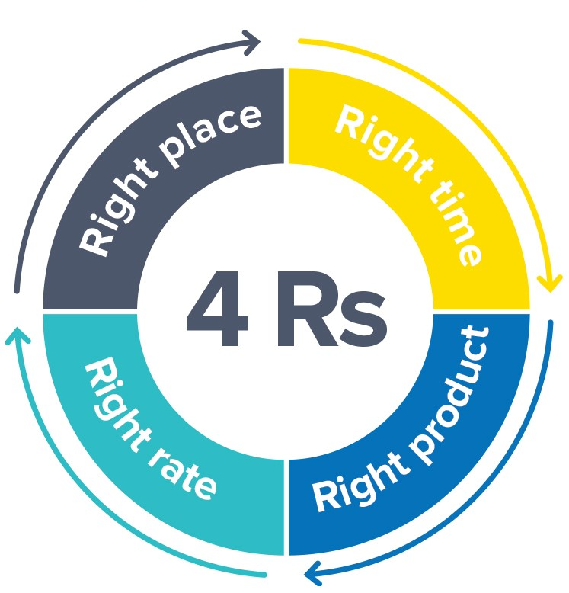

The Table below considers, for each of the 4 Rs, the responsibility, information required, actions, documentation, and competency.

|  |
| --- |
| **Right Product** |
| **Responsibility:**   * **Operator** - note that responsibility can be delegated but a system that records that delegation shall be maintained.   + Collection of correct products (as applicable);   + Assessment of spreadability of product received (as applicable);   + Ensure information related to product safety issues and any precautions required including level of dust are received and understood. * **Nutrient Owner**   + Nutrient budget;   + Nutrient Management Plans (adheres to regulatory requirements);   + Soil test results and adviser recommendations;   + Understand spreadability of product;   + Suitable on-farm storage * **Nutrient Supplier**   + Recipe of all components in a mix and the ratio or percentage of inclusion. Where appropriate, this shall include a Safety Data Sheet   + Nutrient compatibility;   + Identify product precautions, storage life and any special requirements;   + Ensure all the above are clearly communicated to the operator or nutrient owner. |
| **Information required:**   * Recipe of all components in a mix and the ratio or percentage of inclusion. Where appropriate, this shall include a Safety Data Sheet; * Recommended storage life or any special requirements. |
| **Actions:**   * Before commencing, confirm with the client the nutrient application specification, any safety issues (e.g. corrosion) and the application rate and evenness of application requirements. * All nutrients applied should be Fertmark registered. <https://fertqual.co.nz/fertmark/> . A list of certified companies and products can be found here <https://fertqual.co.nz/download/fertmark-certified-companies-and-fertilisers/>. * Information that should be provided, or available on request includes: * **Solid nutrients**    + Size guide number, SGN (the mean particle size);   + Uniformity Index, UI (the particle size range)   + Bulk Density BD (weight per volume) * **Blends and mixtures**   + Physical compatibility of blend components (SGN, UI)   + Chemical compatibility * **Suspension and liquid nutrient**    + Specific gravity |
| **Documentation:**   * Product applied (for aerial - operator daily record and statistical return to CAA). |
| **Competency:**   * The operator shall hold any qualifications required by regulation. |

|  |
| --- |
| **Right Rate** |
| **Responsibility:**   * **Operator**    + Maintained and calibrated application unit;   + Product flowability and physical form;   + Spread pattern/evenness of application (CV%) using best endeavours. * **Nutrient Owner**   + Nutrient Management Plans;   + Agronomic benefits of evenness of application (CV%);   + Soil/herbage test results and adviser recommendations;   + Understand spreadability of product;   + Nutrient compatibility. |
| **Information required:**   * Spread pattern data for the application unit used, where required[1]; * Specification of the application rate (kg/ha or l/ha) for the nutrient to be applied; * Confirmation of flowability/consistency of the nutrient to be applied (solid nutrient). For suspension nutrient confirm the specific gravity (weight per volume). |
| **Actions:**   * Check the condition of product to be applied, (moisture content, flowability, incompatibility for mixtures) and if necessary, measure mean particle size (SGN) and size range (Uniformity Index, UI); * Confirm that a spread pattern is available for the application unit used, where required; * Select appropriate spreading system/device; * Check/verify that the application system has been calibrated (e.g. hopper flow rate, track spacing) |
| **Documentation:**   * Spread pattern data shall be available on request; * Application rate recorded (operator daily record); * Application unit or method used including spreader type, unique identifier, MOD number (aerial only), suspension system and nozzles as appropriate. |
| **Competency:**   * The operator shall hold any qualifications required by regulation. * All pilots and UAV operators shall be competent in relation to their understanding and application of the Approved Aerial Pattern Test Certificate and Spreadmark Certification. |

|  |
| --- |
| **Right Place** |
| **Responsibility:**   * **Operator**   + Verify application area including exclusion areas;   + Electronic proof of application via GPS tracking;   + Tracks/flight paths including buffer zones;   + Identifying environmental risks;   + Operating site conditions for ground spreaders.   + Establish an appropriate bout width without exceeding the CV% for the product being applied. * **Nutrient Owner**   + Electronic file or farm map of application area;   + Identification of environmental risks, sensitive areas, hazards, plus any other relevant site information;   + Investigate the use of well-granulated product to minimise drift. |
| **Information required:**   * Verification of application site – hard copy map or GIS data of the application site and any exclusion areas; * Track spacings (GPS data). |
| **Actions:**   * Where necessary, set appropriate buffer zones around non-target areas; * Log target areas onto GPS system or otherwise verify the location of the target site; * Investigate and implement appropriate measures to manage risk of off-target drift. This may include measures such as buffers, wind breaks, traffic management etc; * Investigate the use of well granulated product to minimise drift; * Investigate spreading units that restricts off-target drift; * Check weather prior to and during application (wind direction, speed etc); * Measure or estimate wind speed and direction using tools such as weather forecasting apps, anemometer, or wind vane/sock; or visual indicators such as smoke, trees, and water; * Where practicable ensure the wind is blowing away from areas at risk of off-target drift and delay spreading until conditions are more suitable. Reassess the spreading of nutrients if the wind picks up or changes direction. |
| **Documentation:**   * Buffer zones set (where required); * GPS plots for the application site; * The type of nutrient applied and the rate of application. |
| **Competency:**   * The operator shall be appropriately trained. |

|  |
| --- |
| **Right Time** |
| **Responsibility:**   * **Operator (note that responsibility can be delegated but a system that records that delegation shall be maintained).**   + Assessment of application site conditions e.g. severe wind, rain, ground conditions;   + Application unit/staff availability; * **Nutrient Owner**   + Nutrient Management Plans;   + Environmental regulations;   + Production requirements   + Soil conditions e.g. temperature, saturation;   + Nutrient availability;   + Communicate relevant details before and at time of application. |
| **Information required:**   * The required or preferred application date; * Weather – particularly wind direction and wind speed. |
| **Actions:**   * Communicate with client to confirm arrangements. |
| **Documentation:**   * Date of application noted (operator daily record); * Adverse events, if any, including jettison or off target application (aerial); * Spreading units used; * Amount applied – statistical returns to CAA (aerial); * Weather conditions (wind speed and direction). |
| **Competency:**   * The operator shall hold any qualification required by regulation. |

The Risk Management Table in Appendix A provides a useful and succinct summary of the risks outlined above, along with their appropriate management response. It is a useful quick reference guide as well as promotional material that is easy for stakeholders to understand.

## 5. Spreading UNIT testing

Spreadmark places limits on the variability of evenness of application that are deemed acceptable. The coefficient of variation (CV%) is obtained from sample trays used in a single transverse test of the spread pattern. The CV% is calculated by taking the standard deviation of the overlapped distribution and dividing by the respective mean and expressing as a percentage. A low CV% means more even spreading. The evenness of distribution is affected by the shape of the individual spread pattern and by the accuracy with which the required bout width or track spacing can be maintained.

**5.1 Principles for the technical framework for spreader certification**

**Scope**

In order to ensure that nutrients are spread according to the requirements of the Spreadmark programme the following principles shall be followed with regard to the testing of nutrient spreading units. Operational matters are covered in the Code of Practice for Fertiliser Nutrient Management <https://www.fertiliser.org.nz/Site/code-of-practice/> .

**Principles**

1. The spreader test procedure allows each spreader to be characterised so it can be set to accommodate variable nutrient characteristics. The test procedure has been linked to international methods and practice, adapted to New Zealand conditions.

2. Both indoor and outdoor testing is permitted for ground spreading units. For outdoor testing, requirements for wind speed and direction, angle of slope and nature of surface shall be set. Outdoor testing shall be carried out in a way that does not cause environmental contamination by overloading the test site. For indoor testing the test facility shall be of such a size as to not interfere with the test result.

3. The evenness of nutrient spreading shall be expressed as a Coefficient of Variation. The evenness of spread both across and along the direction of spreader travel is important. Application rate at the time of test and application rate calibration settings shall be recorded.

4. To be Spreadmark Registered, application units must satisfy the performance standard for transverse CV% of 15% for nitrogenous nutrients and 25% for all other products.

5. The spreadability of nutrients depends on its physical characteristics, usually described by their bulk density (BD); uniformity index (UI); and size guide number (SGN). Spreading units shall be tested on a sufficiently wide range of nutrients to provide a guide to the maximum safe bout width for the range of products the spreader distributes.

6. Spreader certification testing shall be done at frequencies described in Section 3.4 (c) – (e) of the Spreadmark System Standard by Approved Spreading Unit Testers, who shall test spreaders in accordance with Spreadmark Technical Specifications for testing spreaders (refer Booklets 2-4). Testers shall prepare Spreader Performance Certificates and forward them to the company and to the Auditor.

7. Spreader operators should use simple field tools (sieve box and bulk density measure) to estimate these parameters in the field and adjust the spreading units accordingly.

8. Every certified spreader shall have, a unique identification number. For Groundspread vehicles spreader certification lapses if the bin changes to another vehicle.

9. When spreaders are sold from a Spreadmark registered company to another Spreadmark registered company, the current Spreadmark Test Certificates can be transferred to the new owner. When spreaders are sold from a Spreadmark registered company to a non-Spreadmark registered company then the certificates lapse.

**5.2 Technical specification for the testing and certification of groundspread solid nutrient UNITs**

### Refer Booklet 2 <https://fertqual.co.nz/resources/>

### 5.3 Technical specification for the testing and certification of conventional boom sprayers applying liquid nutrient

### Refer Booklet 3 <https://fertqual.co.nz/resources/>

**5.4 SPREAD PATTERN TESTING AND INTERPRETATION FOR AERIAL APPLICATION**

### Refer Booklet 4 <https://fertqual.co.nz/resources/>

**5.5 Guidelines for Checking Spread Patterns (“The Quick Test”).**

**Introduction**

The purpose of these guidelines is to assist companies wishing to check the spread pattern of their nutrient spreaders.

Spread pattern checks should be carried out:

* After damage or a major service of the spreading mechanism,
* Between two–yearly checks to meet the annual spreader checking requirement (see section 3.4 (c) – (e) of the Spreadmark System Standard),
* In order to prepare spreading units for testing by Spreadmark Approved Spreader Testers,
* In order to demonstrate a checking history to substantiate a request for the extension of a Spreadmark Spreader Performance Certificate (see section 3.4 (k) of the Spreadmark System Standard).

The procedure for checking the spread pattern of nutrient spreading units is based on the process used by Spreadmark Approved Spreading Unit Testers but is considerably simpler.

Note that there is a considerable amount of information and background material available to spreader checkers in earlier sections of this Code. Checkers are referred to “Principles for the Technical Framework for Spreader Certification” in Section 5.1 and Technical Booklets referenced in Sections 5.2 – 5.4.

**Procedure**

**Test site**

Select a suitable site for checking the spreaders. This shall generally be outdoors on flat land with relatively short grass. Testing should ideally be either directly into or with the wind. The wind speed should not be so high as to distort the spread pattern (generally up to about 15 kph).

Do not conduct too many tests in the same location to avoid over-fertilising the land.

If testing indoors ensure that the test venue is large enough to give a proper run up and also large enough to avoid ricochet effects.

**Participation**

It is recommended that operators be involved in the testing of spreading units that they drive. This will enhance their knowledge of factors affecting the performance of their units.

**Test products**

Spreaders should be checked with more than one product. The products used for testing should be typical of those normally spread with that unit.

When testing, record the bulk density and the sieve box results for the products used.

**Collectors**

Collectors should be laid out across the direction of travel. Anti-bounce inserts should be fitted. Collectors may be laid out continuously or at one-metre spacings – depending on the number of trays available.



Collectors should collect a reasonable amount of the swath. For most spreaders it has been found that about 20 trays at a one-metre interval provides sufficient information to allow sound assessments of spreader performance to be made.

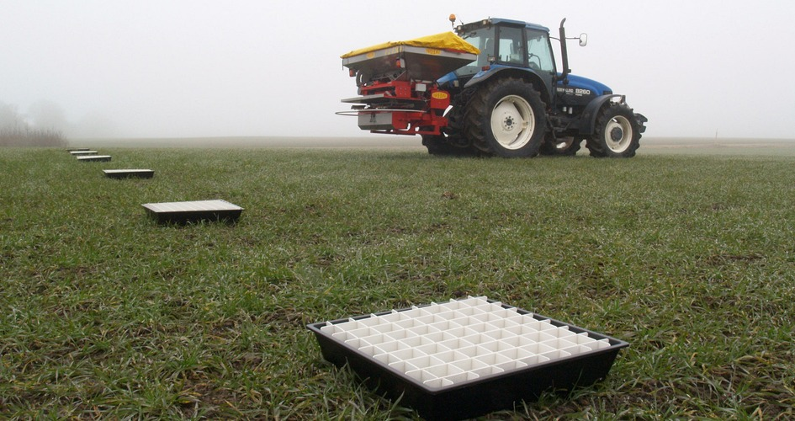

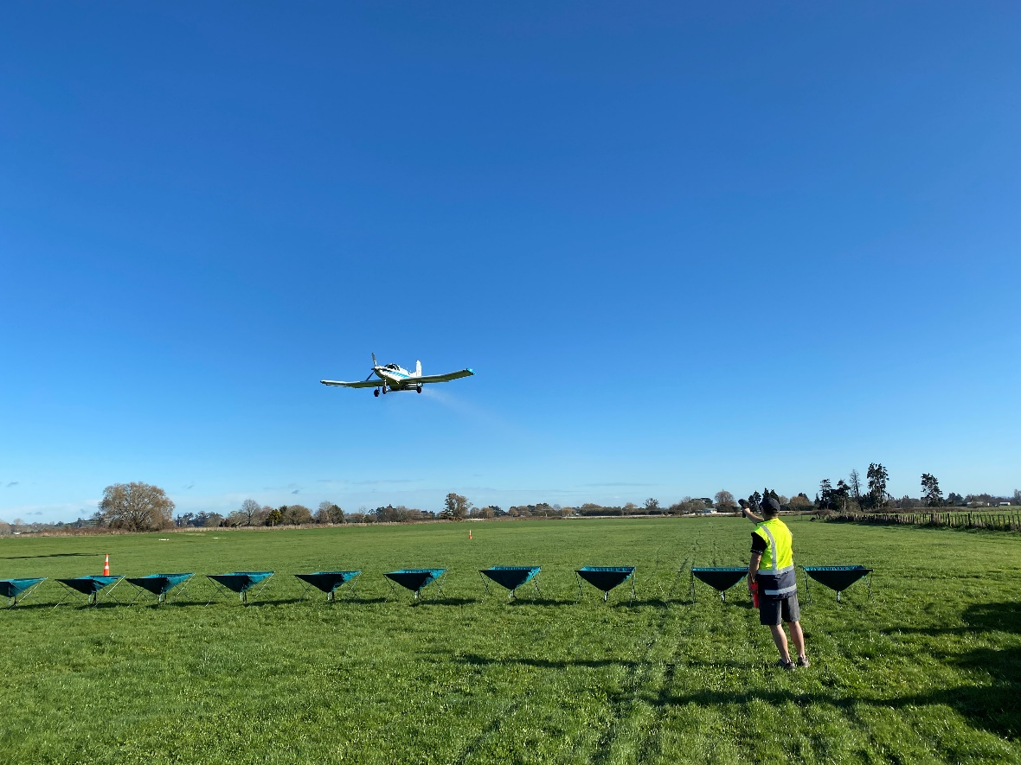

**Material Collected**

The product collected in each tray should be weighed to the nearest 0.1 gram or the volume measured using graduated tubes.

**Graphs**

The test information gathered should then be graphed to produce a spread pattern graph which can be compared with the original test pattern.

In order to demonstrate that the Certified Bout Width remains valid the test information (tray placement vs weight or volume collected) should be loaded into the appropriate computer software found here <https://fertqual.co.nz/resources/>. Alternatively, this service may be available from one of the Spreadmark Approved Testers found here <https://fertqual.co.nz/resources/>.

### 

### 5.6 Collectors approved for use with Spreadmark testing

The list of collector and collector insert designs approved by the Fertiliser Quality Council for use in Spreadmark testing can be found here <https://fertqual.co.nz/resources/>

Organisations wishing to have an additional collector and collector insert designs approved should advise the Executive Director, Fertiliser Quality Council at [director@fertqual.co.nz](mailto:director@fertqual.co.nz) with an appropriate comparative test report.

**APPENDIX A**

**RISK MANAGEMENT TABLE**

|  |  |  |  |
| --- | --- | --- | --- |
| **Factor** | **High Hazard** | **Low Hazard** | **Comment** |
| Wind speed | Product drifts off application area  Potential to cause 3rd party or environmental risk | Product remains within application area  Unlikely to cause 3rd party or environmental risk | Measure or estimate using anemometer or visual indicators such as smoke, trees, and water |
| Wind direction | Unpredictable | Predictable and away from sensitive areas | Use wind vane/sock or visual indicators such as smoke, trees, and water |
| Granular size | Less than 1mm (dust) | Greater than 1mm | Larger granules reduce the risk of drift |
| Sensitive area | Potential to cause contamination | Unlikely to cause contamination | Identify sensitive areas on work plan and site map or GPS electronic file |
| Buffer zone | None | Yes | Guideline only. Identify appropriate buffer zone on work plan or on-site risk assessment |
| Shelter belts | No shelter | Effectively minimises product drift | Applies to ground spread methods |
| Operator control | Unmanned or automatic control mechanism | Manned or manually controlled mechanism | On-board applicator or manually controlled mechanism quicker to respond to changes in risk during operations |
| Ecotoxicity | High ecotoxicity | Low or no toxicity | Apply appropriate buffer zones |
| Nutrient quality | High granule variability or blends | Low granule variability or uniform granules | Evenness of spread within CV specifications |
| Nutrient flowability | High moisture content and/or lumpy product | Low moisture content free flowing product | Safely jettisons from an aircraft hopper  Evenness of spread within CV specifications |

|  |
| --- |
| NOTE –   1. The potential drift hazard scale is given as high or low, and intermediate situations should be rated accordingly. 2. All the weather-related factors are to be assessed on-site at the time of application. 3. CAA Rule Part 137 requires that the operation of aeroplanes above the MCTOW have a minimum jettison capability of at least 80% of the maximum permitted load within 5 seconds for the configuration being used |

1. Refer Section 3.4 (a) and (b)